Docker image create job

* Install Docker and git in Jenkins server
* Follow the Jenkins file (environment followed passed in the stages)
* Here Jenkins Credentials passed by PAS (personal access tokens)

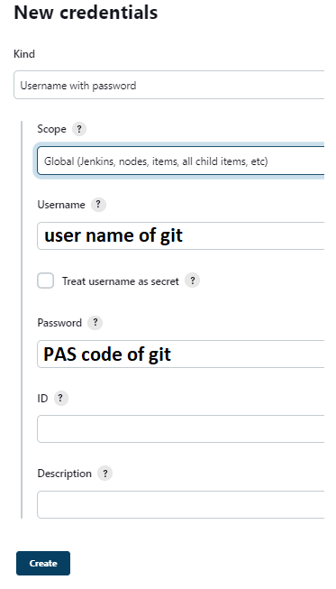

* If you followed PAS verification then follow with https link of git branch
* DockerHub credentials by username and passwords

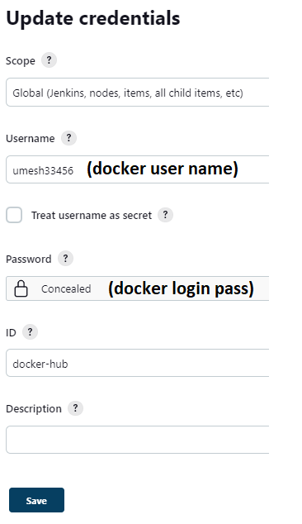

Note: Please check that Jenkins file how Passed build details and Docker Hub credentials.

( registry, registryCredential, dockerImage these details followed in stages too )

* Pushed Docker images to DockerHub

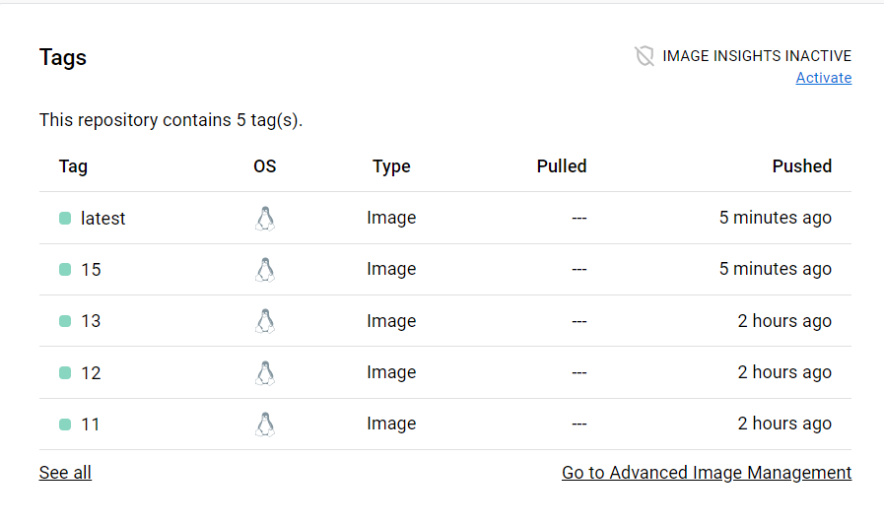

|  |
| --- |
|  |
|  |  |
|  |  |

* Docker tag of build success

